# The Battle of Neighborhood — Arabic Coffee Shop in London

By: Ahmed B Darwish

[abdarwish@outlook.com](mailto:abdarwish@outlook.com)

**1. Introduction**

**1.1 Background**

As one of the largest English cities, London has one of the most ethnically diverse population in the world. It is considered to the world’s cultural capital with a diverse range of cultures and people. Even though English is the official Language in London, there are over 300 languages spoken in the city. According to the 2011 census, over 36.7% of the London residents or 2,998,254 people are foreign-born, which is the second largest population of immigrants in the world right behind New York. Some of the largest ethnic groups in the city include Arabs, Chinese, Bangladeshis, Pakistanis, Indians, and Africans.

Because of the multitude of civilizations, London attracts investors from all over the world and it is one of the best investment cities in the world.

**1.2 Problem**

My friend asked me to help him exploring London city and choose the best location for his business as he is going to open an Arabic Coffee shop in London. He wants to provide authentic Arabic coffee to Arab and non-Arab people, so that the community knows the ancient original Arab culture, and he believes that there is no much competition in this field.

Arabic coffee is a version of the brewed coffee of Coffea arabica beans. Most Arab countries throughout the Middle East have developed distinct methods for brewing and preparing coffee. Cardamom is an often-added spice, but it can alternatively be served plain.

It was agreed that the location of the business should be close to the main most popular venues and neighborhoods in London, also the presence of Arab and Turkish restaurants would be an advantage.

In this project, we will Scrap London Boroughs, Neighborhoods and Postcode data from Wikipedia, then using geopy library to convert postcodes addresses into their equivalent latitude and longitude values.

After that, we will get the top 10 venues for each Neighborhood using Foursquare API, and using clustering K-Means algorithm to group the neighborhoods into clusters. We will also visualize the neighborhoods in London City and their emerging clusters using Folium library.

Finally, we will choose the best location for the business based on the criteria mentioned above.

**2. Data acquisition and cleaning**

**2.1 Data sources**

This project will rely on public data from Wikipedia which has the list of area of London with the postcode. And from Foursquare API to get the most common venues for each neighborhood. This data will help us exploring London neighborhoods and find the best location for the Arabic coffee shop business.

**2.1 Data Cleaning**

Data downloaded or scraped from multiple sources were combined into one table. There were many unwanted columns and raw’s that has been cleared using pandas library

# 3.0 Methodology

**3.1 Analysis methodology**

To find the best suitable location for this business we will follow below Methodologies:

1. Scraping list of area (neighborhoods) in London with Postcodes from Wikipedia
2. Get the location latitude and longitude for each neighborhood in London
3. Select the borough that has maximum number of neighborhoods. “Barnet”
4. Highlight top 10 Neighborhoods in Barnet based on number of venues.
5. Get the top ten most venues for each neighborhood in Barnet.
6. Cluster all Neighborhoods in Barnet based on their location.
7. Select the cluster that has Middle Eastern Restaurants.
8. Nominate the neighborhood that is among the top ten Neighborhoods in Barnet

# 4.0 Exploratory Data Analysis

* 1. **Scrapping data**

To find the best suitable location we will follow below Methodologies:

* Scraping list of area (neighborhoods) in London with Postcodes from below Wikipedia link: <https://en.wikipedia.org/wiki/List_of_areas_of_London>

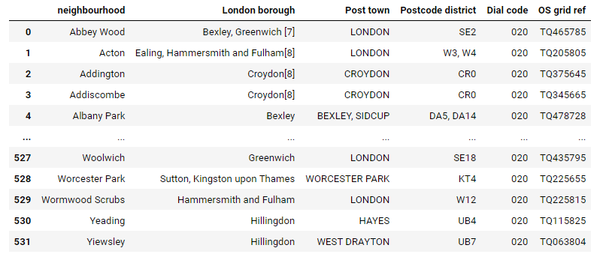

* Using geopy library to add Location Latitude and Longitude columns corresponding to each Neighborhood/postcode

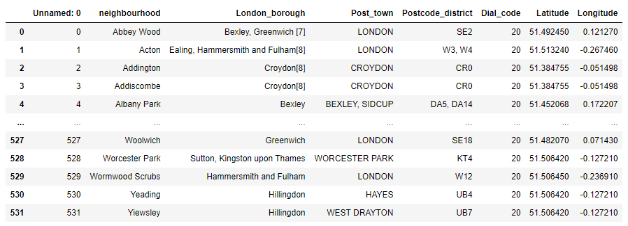

* Using folium library, we plotted the neighborhoods location on the map as shown below ...

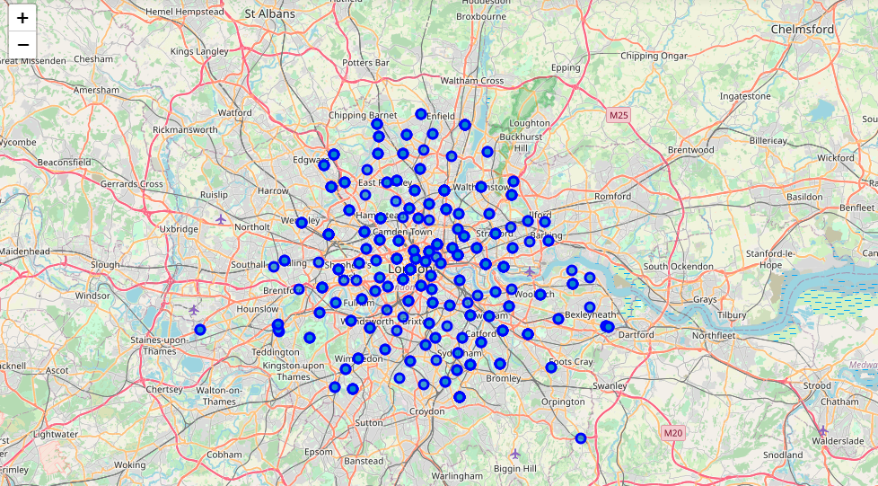

* 1. **Number of neighborhoods for each borough**
* From below We found that London Borough of Barnet has 28 of neighborhoods, so, we will select London Borough of Barnet as a target location for the business.

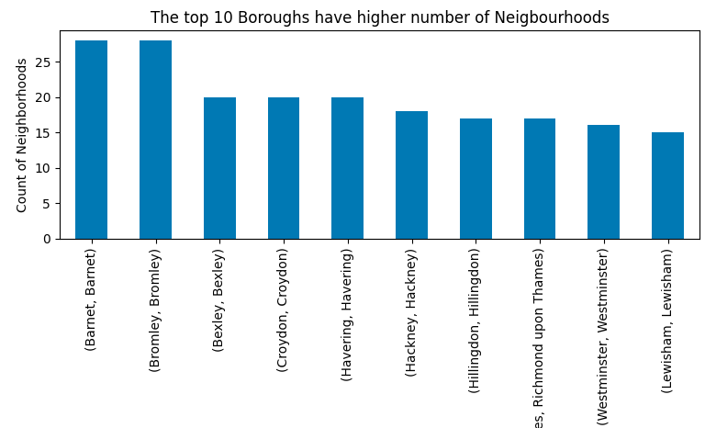

* Exploring London Borough of Barnet

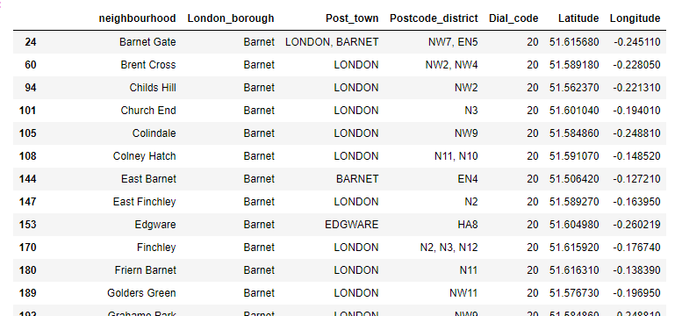

* Plotting all Barnet Neighborhoods using folium library

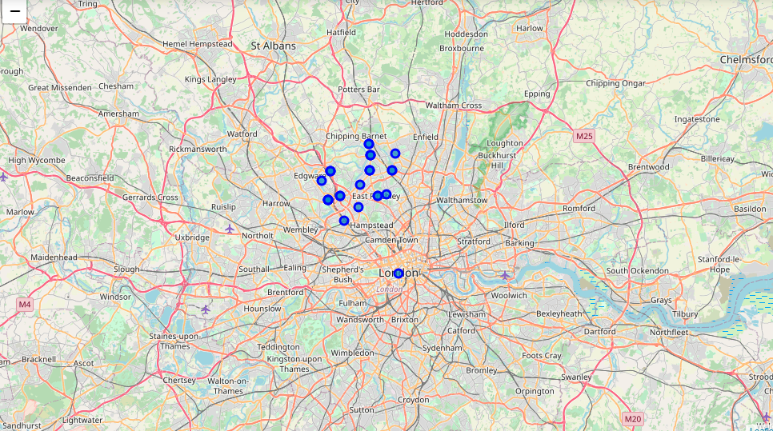

* 1. **Getting venues information from Foursquare API**
* Getting all venues in Barnet and their location from Foursquare API

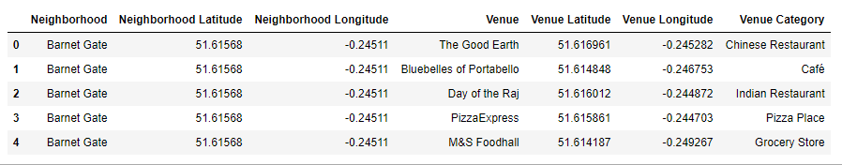

* Below are the Top 10 Neighborhoods in Barnet with high Number of Venues.

Note: the business location should be near to one of these 10 neighborhoods.

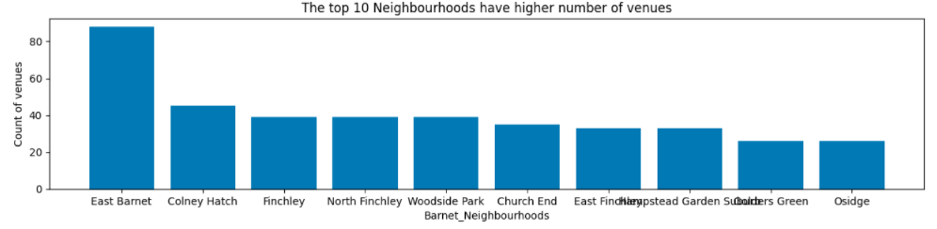

* 1. **Most common venues for each Neighborhood**
* Mapping top ten most common venues for each neighborhood in Barnet

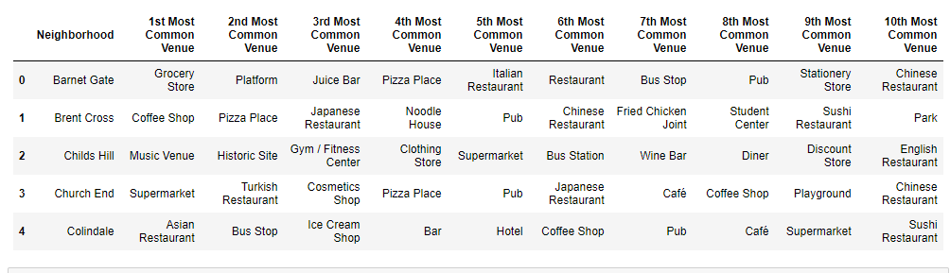

* 1. **Clustering Neighborhoods**
* Clustering Barnet neighborhoods using k-means algorithm to find out the neighborhood that has Middle Eastern and Turkish Restaurant as well as in the top 10 Neighborhoods in Barnet.

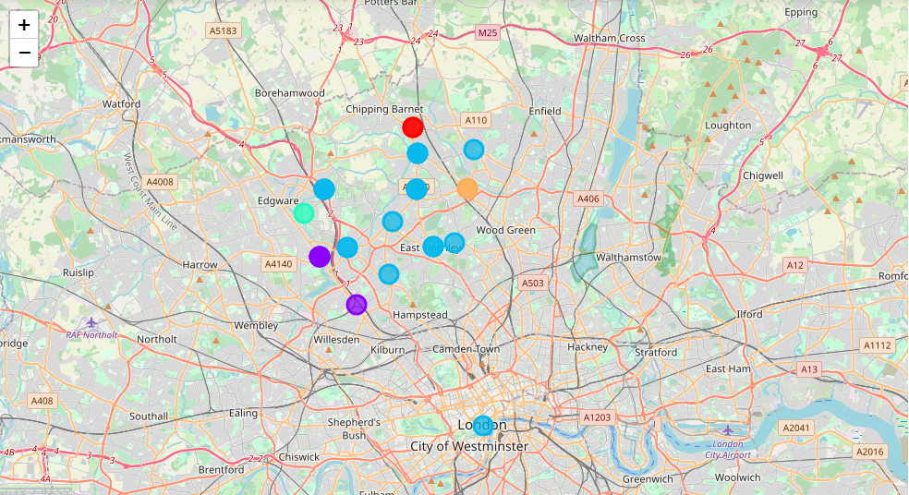

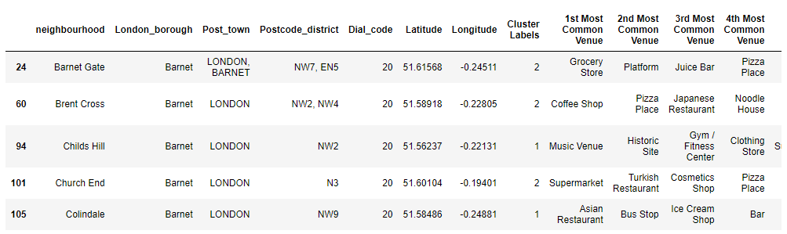

* Cluster 3 the only cluster that has Middle eastern Restaurants, in the top 10 most common venues.

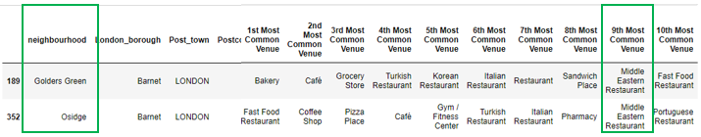

* 1. **Business Location (Problem Solved)**
* Golders Green Neighborhood are nominated to be the location for the business as the   
  site has all the necessary specifications for the success of the project.

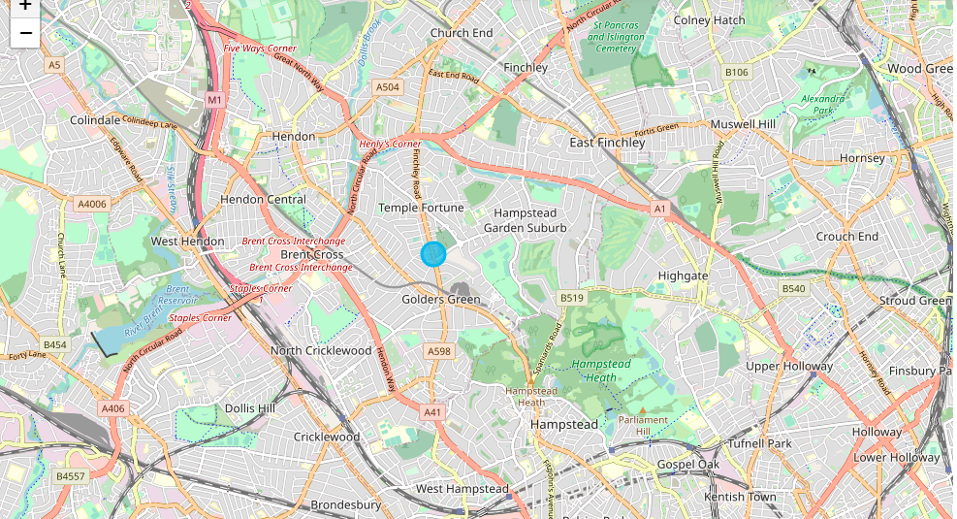

## **5. Result and Findings**

1. Barnet and Bromley Boroughs both have 28 Neighborhoods in the top compared to other Boroughs in London, for simplicity we selected London Borough of Barnet to Explore.
2. East Barnet Neighborhood has the Max. Number of Venues (88 venues) based on Foursquare data
3. Top 10 Neighborhoods in Barnet based on Number of venues are: East Barnet, Colney Hatch, Finchley, North Finchley, Woodside Park, Church End, East Finchley, Hampstead Garden Suburb, Golders Green, Osidge
4. It is important to Open Arabic Coffee Shop business near to Middle Eastern Restaurants.
5. Cluster 3 the only cluster that has Middle eastern Restaurants, in the top 10 most common venues
6. Only Golders Green and Osidge neighborhoods have Middle Eastern Restaurants in their Most Common Venues.
7. The Best Location for the business recommended to be nearby **Golders Green** neighbourhood because it is in the top 10 neighborhoods in Barnet in terms of number of venues